Draft NPA version 4, dated March 8, 2021
Commenter:
Name: Enter name here |  |  | 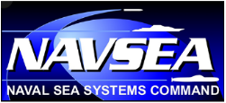
Affiliation: Enter affiliation here
Email: Enter email here
Comment Number | Document Section | Line No. | Comment
ADD EXTRA ROWS AS NEEDED.

INSTRUCTIONS:
- When saving this document, please add your initials to the end of the document title.
- Please submit comments to the Navy SIOP NPA Archive: CR_SIOP_Archive@aecom.com.

OTHER NOTES:
Use this section to provide additional comments.

